Chapter 11, Problem 18.

Find the value of Z_{L} in the circuit of Fig. 11.49 for maximum power transfer.

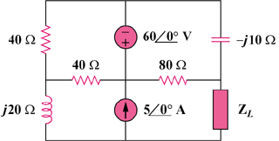

j30 Ω

Figure 11.49
For Prob. 11.18.

